Assignment 04

Formal Methods

malik Abdullah (fa16-bse-101)

muhammad ABdullah (fa16-bse-057)

shahzaib munawar (fa16-bse-047)

2019

GharPey

# PROJECT MODULES

1. User management
2. Shop management
3. Product management
4. Payment Gateways
5. Reports & Analysis
6. Products Q&As
7. Notifications

# STATE SCHEMA OF THE PROJECT

# operational schemas

## User Management

## Shop Management

## Product Management

## Payment Gateways

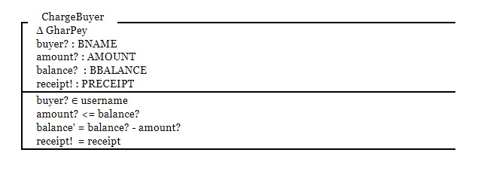

## Reports & Analysis

## Products Q&As

## Notifications

# Activity Diagram 1:

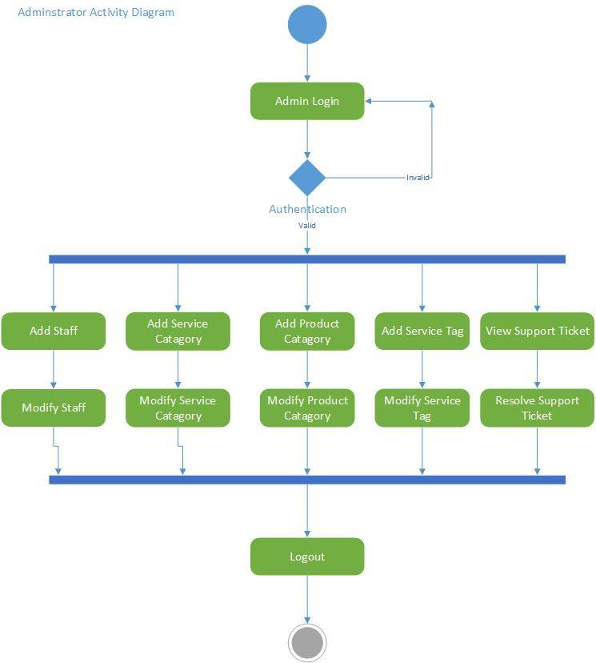

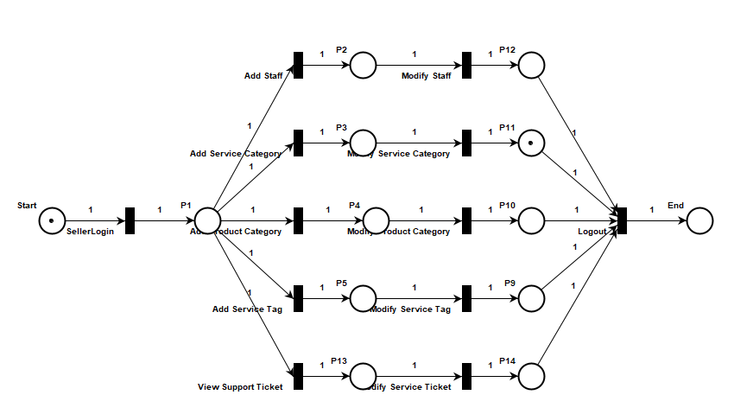

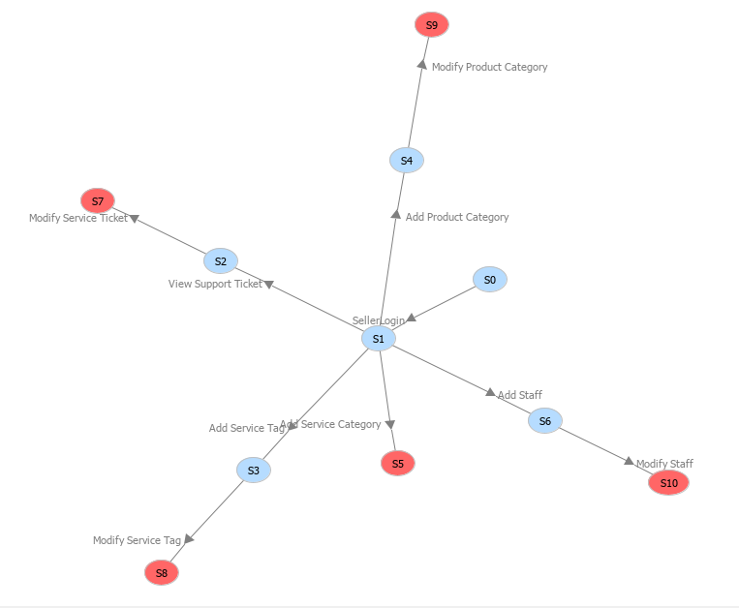

# Activity Diagram 2:

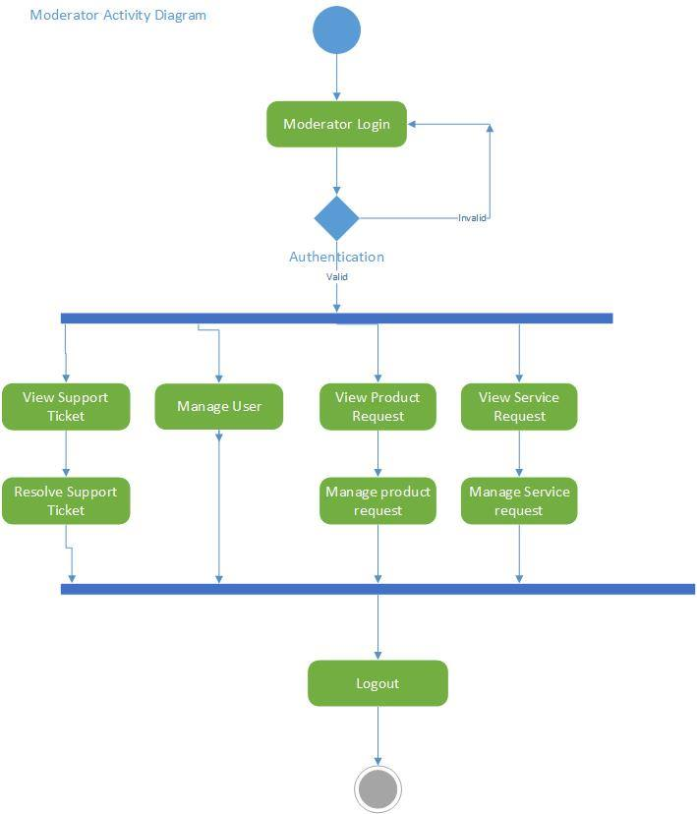

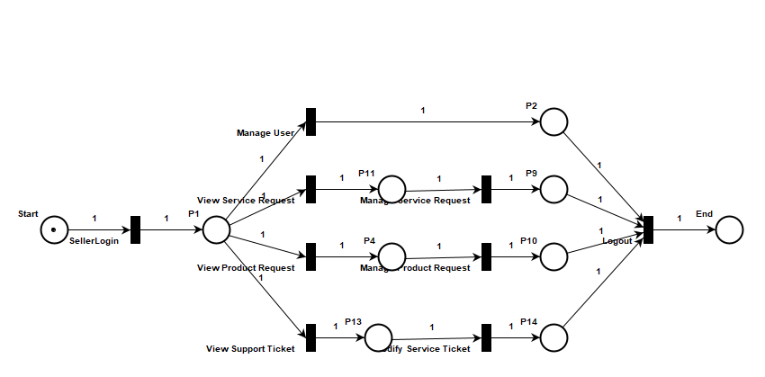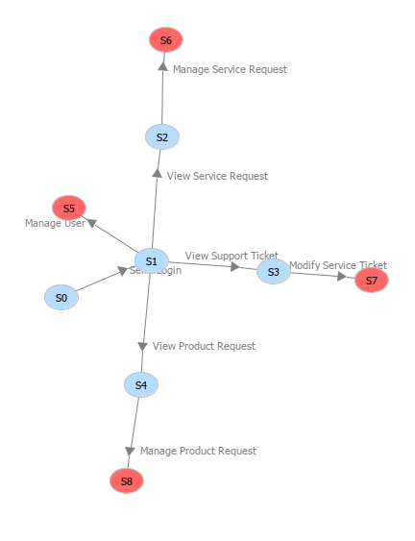

# Activity Diagram 3:

# 

